Biology, Castle View High School  
Jason R Mayberry, PhD

**Study Guide: Introduction to Organic Molecules**

Vocabulary

1. Proteins
2. Nucleic Acids
3. Carbohydrates
4. Lipids
5. Carbon Skeleton
6. Functional Groups
7. Polymer
8. Monomer
9. Condensation
10. Hydrolysis

Short Answer

1. Briefly Describe the roles each of the 4 organic Molecules plays in a cells structure and function
   1. Lipids

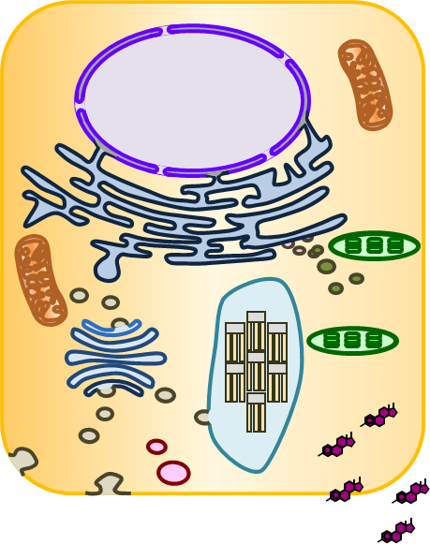

* 1. Nucleic Acids

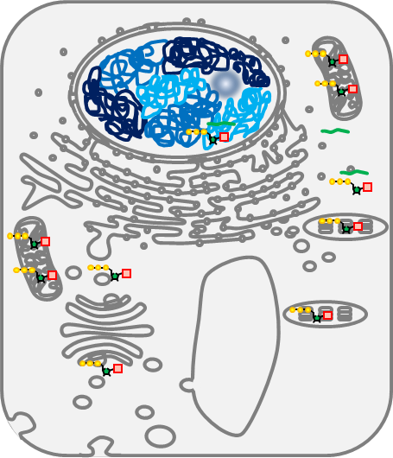

* 1. Proteins

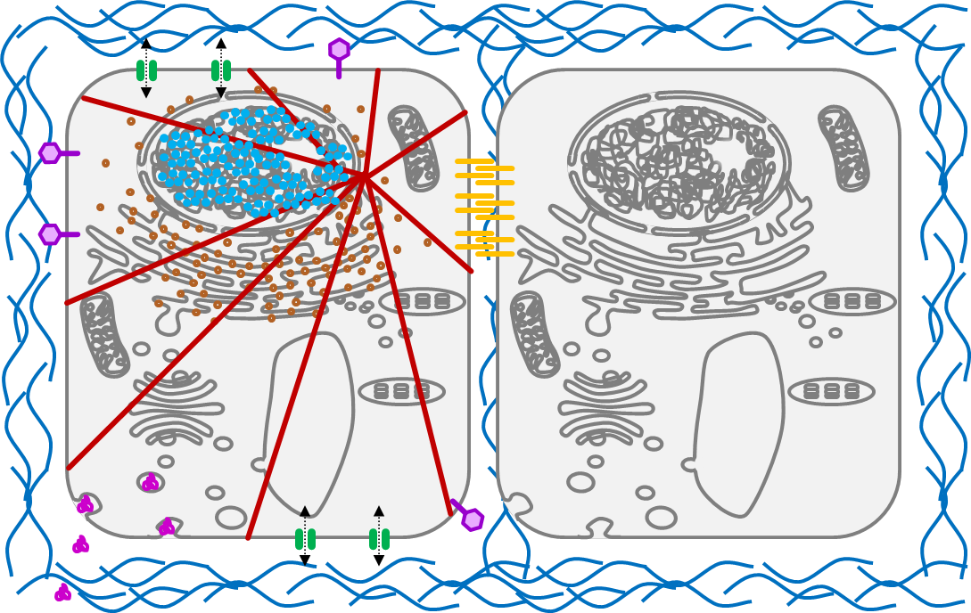

* 1. Carbohydrates

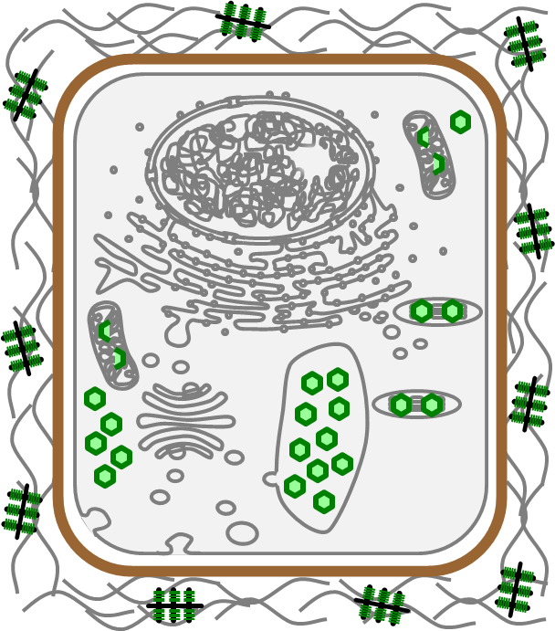

1. What is the role of the Carbon Skeleton in Forming Organic Molecules

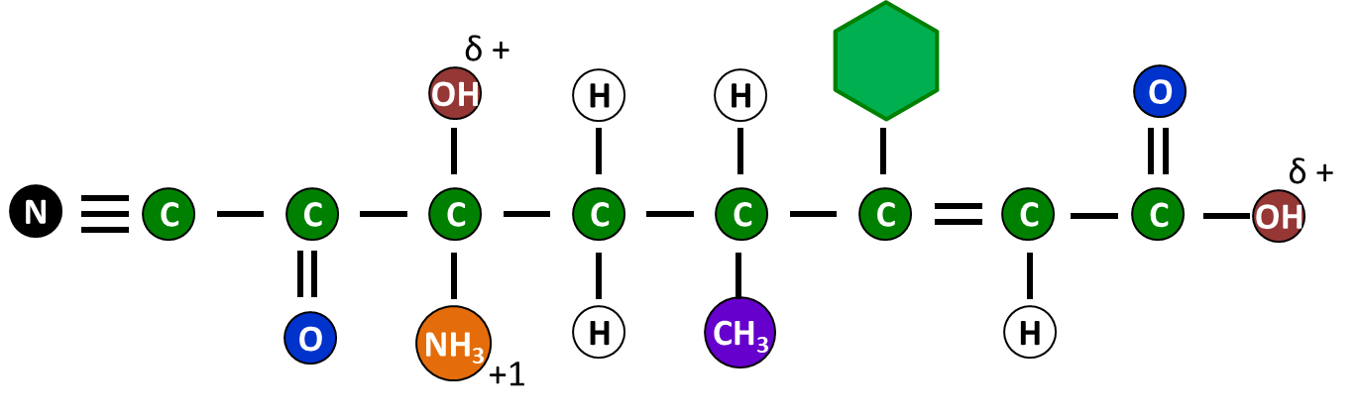

1. What is the role of Functional Groups in Organic Molecules
2. When using Line Drawings in Organic Molecules, what does each corner represent?
3. What is the relationship between a Monomer and a Polymer?



1. Describe what happens during a Condensation Reaction.

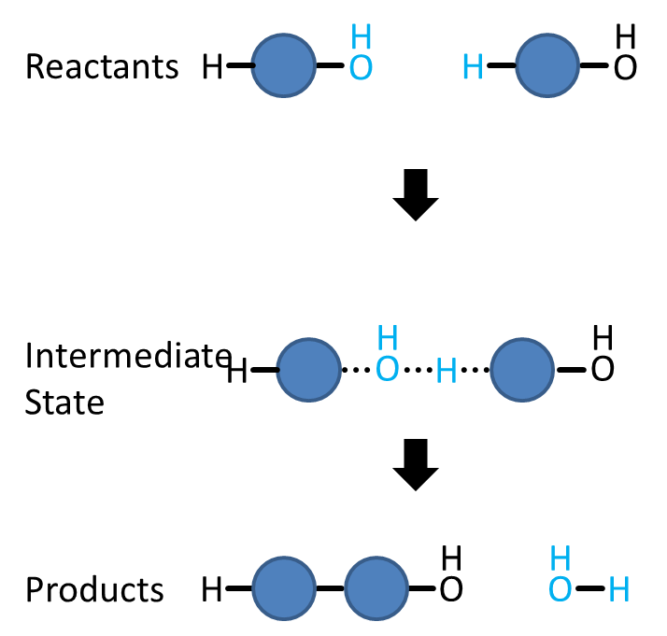

1. Describe what happens during a Hydrolysis Reaction.

